Technical Report

(PHP E Commerce)

Contents

Introduction 4

Technology Stack 4

Frontend 4

HTML 4

CSS 4

JavaScript 5

Backend 5

PHP 5

Database 5

MYSQL 5

Features 6

Customer/Admin Login 6

Home 10

Item Information 11

Add Items to Cart 12

Buying History 13

Update Cart Dynamically 14

Sell Items 16

Create Account 18

SRS Diagram 19

Conclusion 20

# Introduction

The new-tech mobile store is E-commerce mobile store platform that provide a user-friendly Shopping experience for customers. It is designed using a robust technology stack. This platform offers a wide range of features and functionalities to cartes to the needs of modern Ecommerce businesses.

At the bottom of the application lies a powerful combination of server-side technologies, including PHP and MySQL. PHP serves as the backbone of the application. That handle application logic, data-processing, and server-side operation. HTML,CSS, and JavaScript are employed to create a imtutive and visually appearing user interface, ensuring a smooth browsing and navigation experience for customers

In addition, the Online E-commerce Mobile Store makes use of PHP Mailer Functions to enable smooth customer contact. It is used to send confirmation codes sent automatically thanks to this technology/

The MySQL database acts as the primary location for storing and maintaining product information, customer data, and order details, with an emphasis on security, scalability, and performance. Efficient data handling and retrieval are ensured by this strong and dependable database management system, meeting the expanding demands of the e-commerce platform.

# Technology Stack

## Frontend

### HTML

For building this web application frontend HTML is mainly used.

### CSS

For add design and style to website using CSS and it gives customer good UI/UI experience to the customer. The bootstrap CSS library used to add mobile responsiveness and it help developers to do less writing code, and smoothing the UI experience o website’s visitors

### JavaScript

Using JavaScript for this E-commerce web application it gives fundability to this website.it helps customers to gives smooth UI experience.

## Backend

### PHP

PHP, a powerful server-side scripting language, plays a crucial role in the Online E-commerce Mobile Store. It serves as the backbone of the application, handling various tasks such as processing user input, interacting with the database, generating dynamic content, and managing session data. PHP's flexibility and ease of integration with HTML make it an ideal choice for building robust web applications. Additionally, its extensive library of built-in functions and third-party extensions facilitate the development of complex features, such as user authentication, form validation, and file uploads.

## Database

### MYSQL

The Online E-commerce Mobile Store relies on the MySQL database management system to store and manage its data. MySQL, known for its speed, reliability, and scalability, serves as the central repository for product information, customer details, order records, and other critical data. Its robust querying capabilities and support for transactions ensure data integrity and consistency throughout the application. MySQL's ability to handle large volumes of data and its ease of integration with PHP make it an excellent choice for powering the e-commerce platform's data storage and retrieval needs.

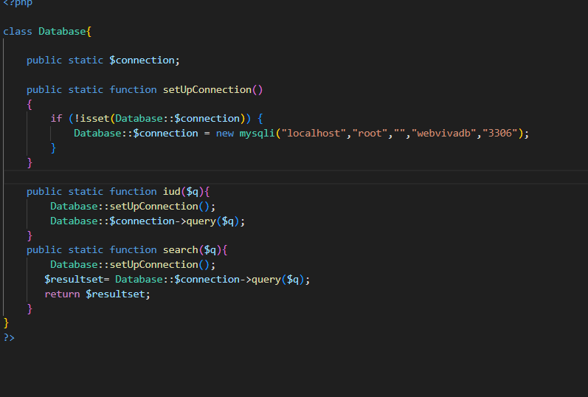

# Features

## Customer/Admin Login

The Online E-commerce Mobile Store prioritizes data security and privacy by implementing a robust login system for both customers and administrators. This feature ensures that only authorized individuals can access sensitive information and perform specific actions within the application.

For customers, the login functionality enables them to create personalized accounts, store their personal data securely, and maintain a record of their order history. By entering their registered email addresses and passwords, customers can access their profiles and manage their account details, shipping addresses, and payment methods, streamlining the checkout process for future purchases.

On the other hand, the admin login system provides authorized personnel with access to the administrative panel, where they can manage various aspects of the e-commerce platform. This includes tasks such as updating product catalogs, monitoring orders, generating reports, and maintaining customer records. Robust authentication measures, including secure password storage and access control mechanisms, ensure that only authorized administrators can access and modify critical data, safeguarding the integrity and confidentiality of the system.

Overall, the login feature plays a crucial role in protecting user data, maintaining privacy, and ensuring a secure shopping experience for customers, while also enabling efficient management and oversight for administrators

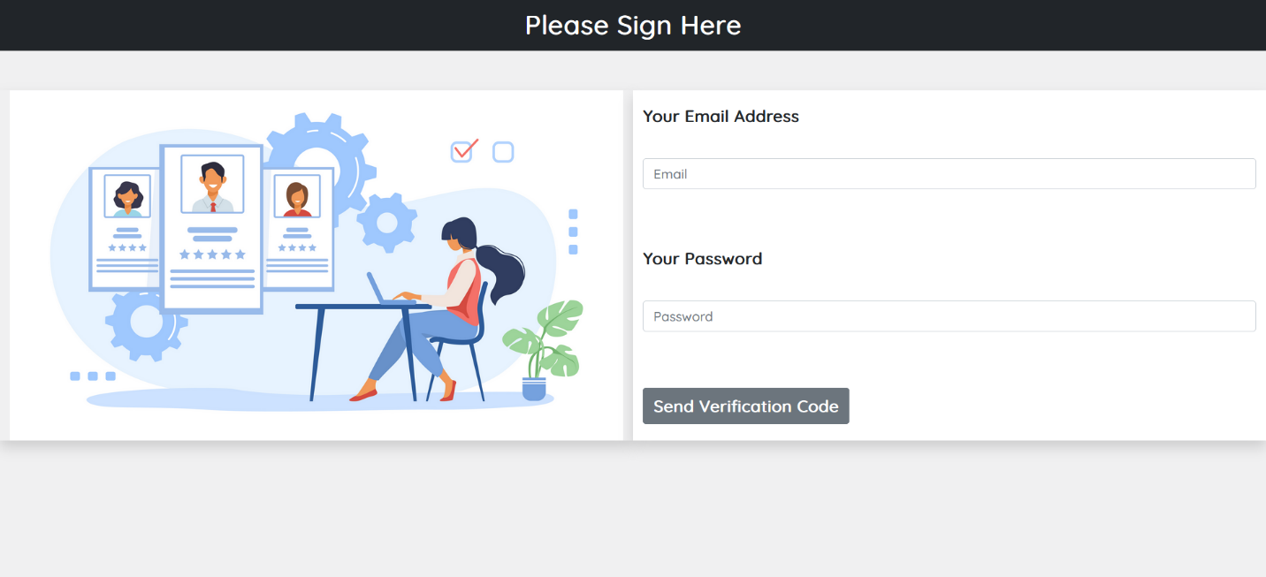

## Home

The home feature shows the item, and add slider to the web page enhance use experience also in home page all the item are listed as categories

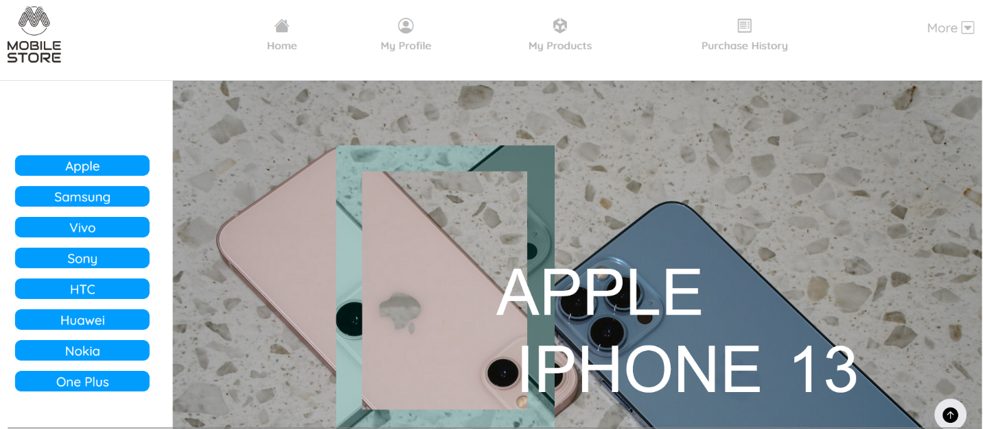

## Item Information

In this web application there is feature when product buy now button pressed it redirect to the page that show all the item information relevant to the item. It is very useful for the customer to get know about full details view of that customer buying item.

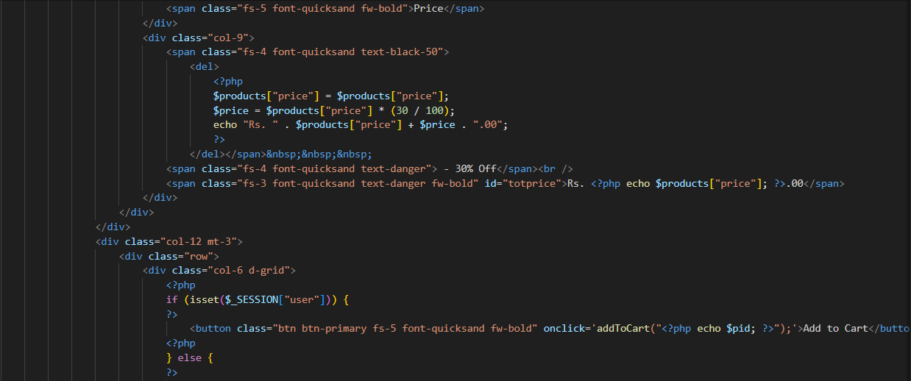

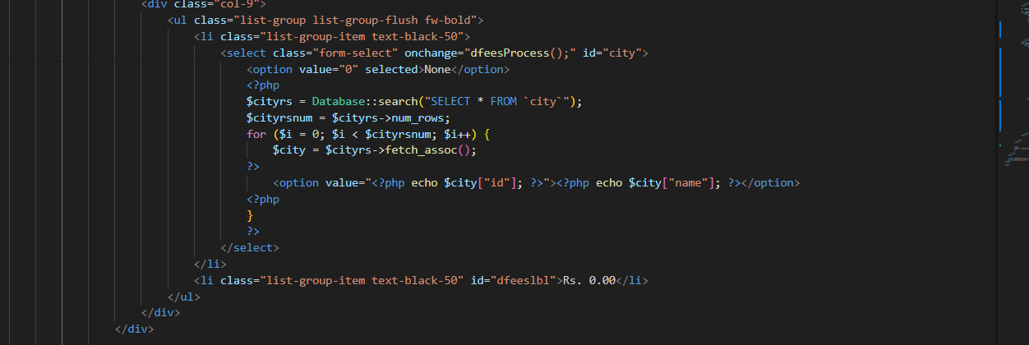

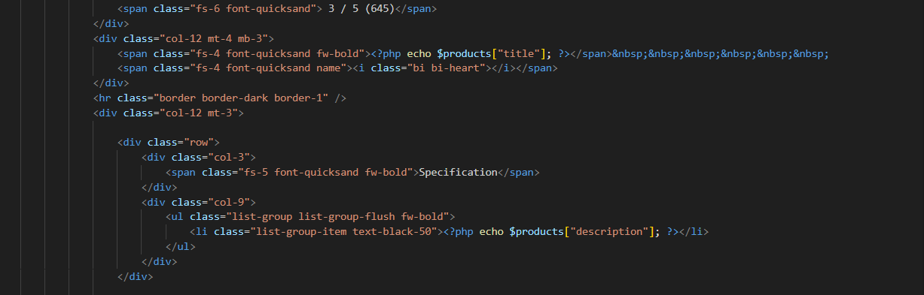

## Add Items to Cart

Customers can browse through different products from different product categories. They can add items to their shopping cart dynamically.

## Buying History

User’s can see their buying history and like graph view. It can hlp user to the what’s they buying. If customer forgot what the item they buy it an see narrow the search using item buying dates.

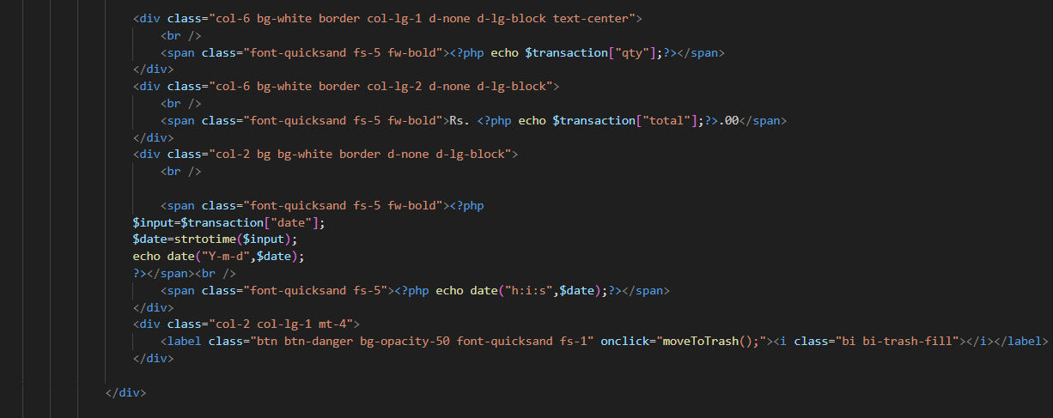

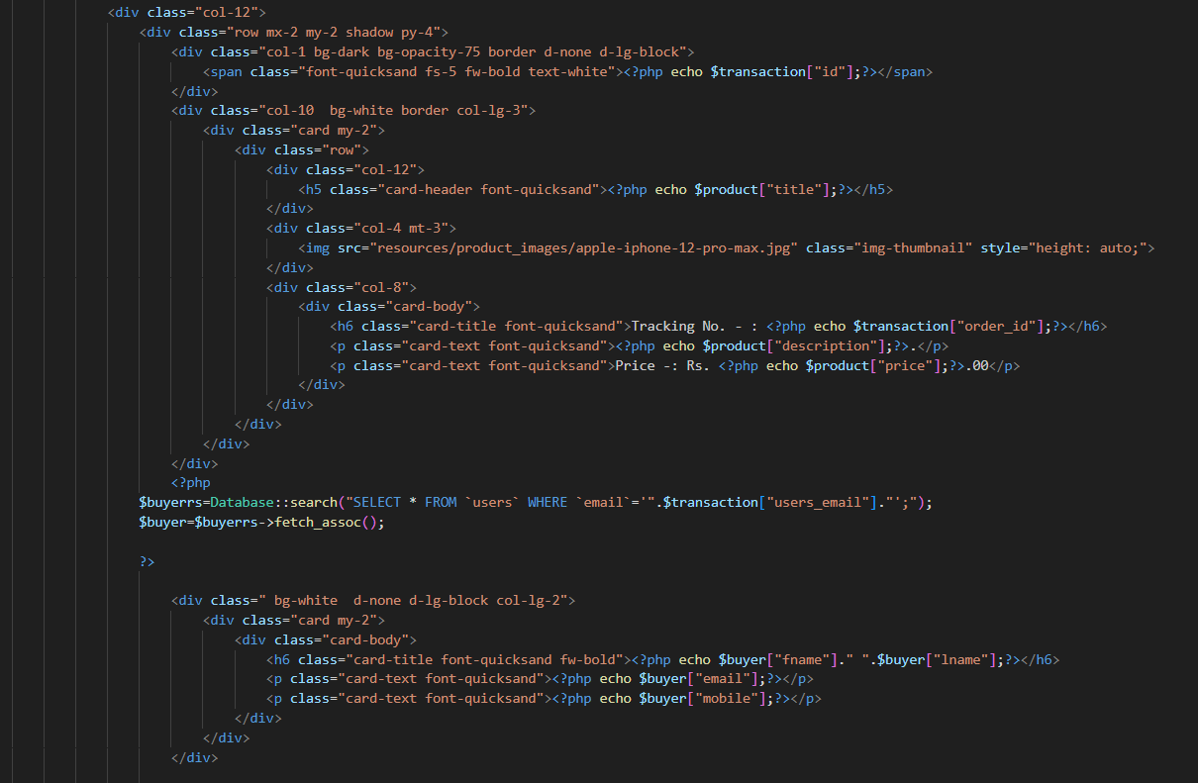

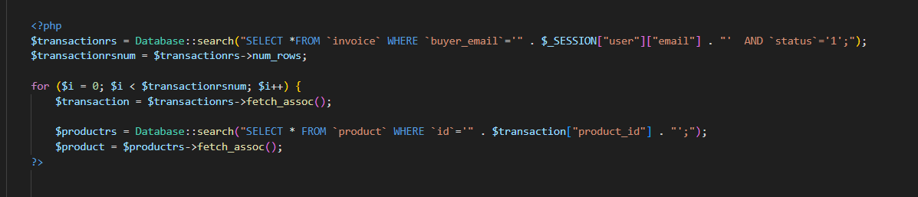

## Update Cart Dynamically

Dynamically updated cart implemented for this program.it can get real time updates when use add item or remove item from the cart and total price. It helps to smooth experience to the customer.

## 

## 

## Sell Items

User can list their items for sell. if user want to sell brand new or used electronic item this the suitable place for them.

## Create Account

The Online E-commerce Mobile Store offers a seamless registration process for new customers. To create an account, users are required to provide their personal details, such as name, email address, and contact information. Additionally, they must set up a unique username and secure password for their account.

To ensure the authenticity of the provided email address and enhance account security, the website employs PHP Mailer Functions. Upon registration, a verification code is sent to the user's email address. This step confirms that the email address is valid and accessible by the user. Furthermore, the email verification process comes into play when users forget their passwords, allowing them to reset their credentials securely.

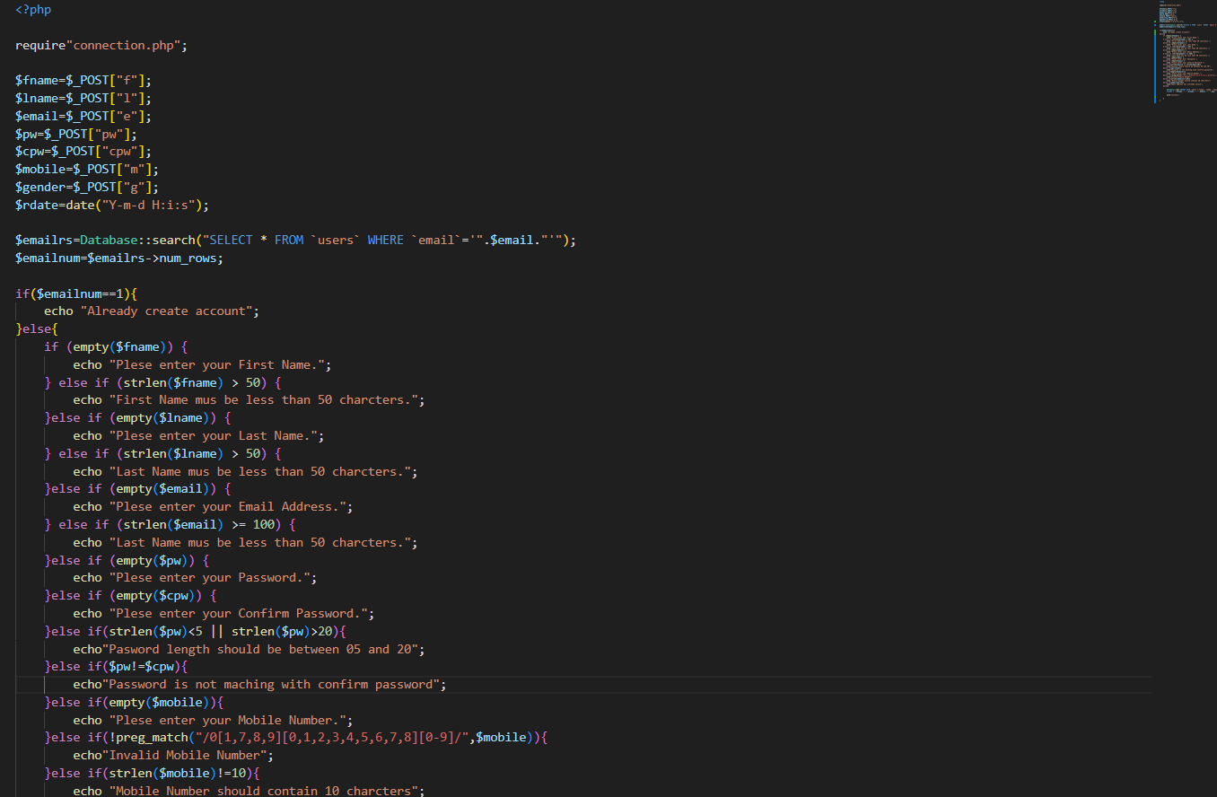

# SRS Diagram

The Software Requirements Specification (SRS) diagram is a visual representation of the key components, modules, and functionalities required for the Online E-commerce Mobile Store. It serves as a blueprint for the system's architecture, depicting the various modules responsible for user management, product catalog, shopping cart, checkout process, administration, email notifications, and database operations. The diagram illustrates the relationships and interactions between these modules, providing a comprehensive overview of the system's structure. By clearly defining the system's requirements and components through the SRS diagram, it facilitates effective communication among stakeholders and guides the development process, ensuring the successful implementation of the e-commerce platform

Given Below Diagram is ERD Diagram one of type of SRS Diagram.

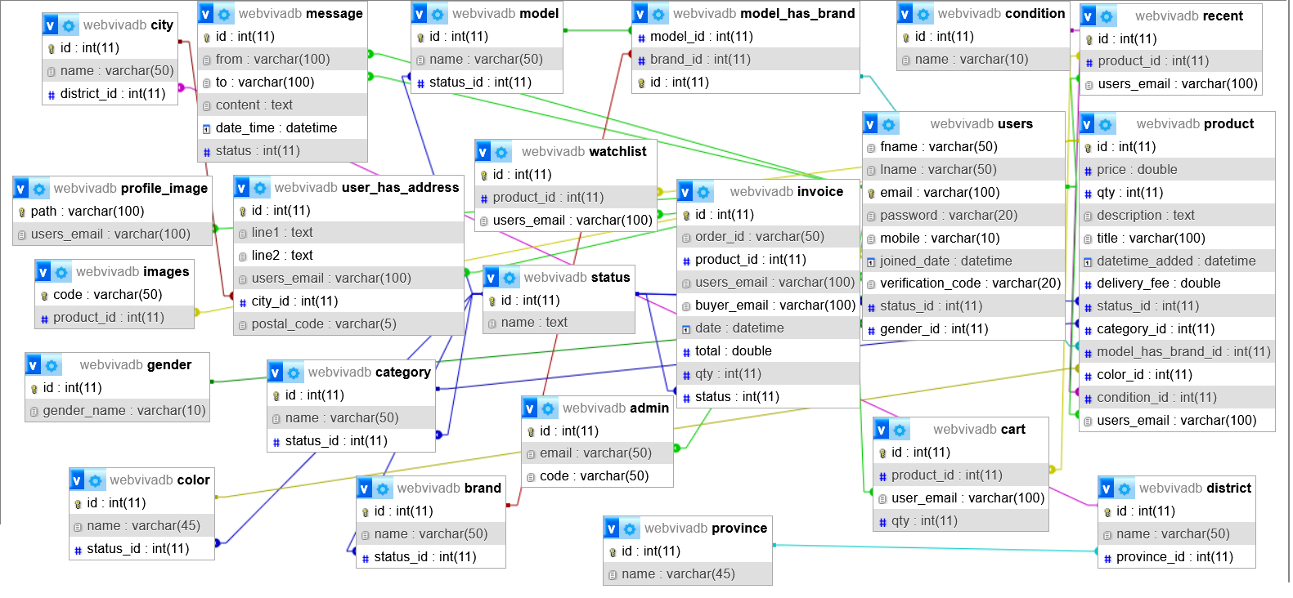

# Conclusion

The Online E-commerce Mobile Store offers a seamless and user-friendly shopping experience through its thoughtfully designed platform. Customers can effortlessly navigate the website, exploring a wide range of product categories and adding desired items to their virtual shopping cart with just a few clicks. The dynamic cart system allows users to modify quantities or remove items as needed, providing flexibility throughout the browsing process.

Upon checkout, customers can complete their purchases by entering shipping and payment details. The robust account creation feature enables new users to register and save their personal information securely for streamlined future transactions. Throughout the purchasing journey, the website keeps customers informed through timely email notifications powered by PHP Mailer Functions.

Underpinning this user-friendly e-commerce experience is a robust technology stack comprising industry-standard tools and frameworks. The website's front-end is built using HTML, CSS, and JavaScript, ensuring a visually appealing and interactive user interface. On the back-end, PHP handles server-side logic and database interactions, while MySQL serves as the reliable data storage solution. This powerful combination of technologies ensures a smooth, efficient, and secure online shopping experience for customers.